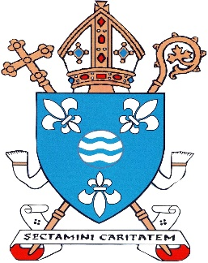
Rt Rev. Joseph Toal STB KC*HS Bishop of Motherwell

Diocesan Centre
Coursington Road
Motherwell
ML1 1PP

2021 Safeguarding Statement for Parishes and Organisations in Motherwell Diocese.

Since my statement on Safeguarding last February, the restrictions brought in because of coronavirus have disrupted a lot of normal parish life and curtailed many activities run by organisations and groups in the Diocese of Motherwell. It has been necessary though to ensure the continued safety and protection of all who come to worship in our churches and take part in the limited activities permitted in parishes at present. The Diocesan and Parish Safeguarding teams have been working therefore to ensure that our Safeguarding Structures remain in place, and have also ensured that any present concerns raised in parishes have been properly handled, while also addressing matters reported from the past.

I thank our Parish Priests and Parish Safeguarding Coordinators, our Religious Communities, and our Diocesan and Parish Organisations who have recently completed the Annual Safeguarding Audits. In March, an external independent audit of the Motherwell Diocesan Safeguarding Service, asked for by the Independent Review Group, will take place. Although a lot of preparatory work has been required and the audit is expected to be demanding, we anticipate that the it will be beneficial and that the recommendations made will help improve our Diocesan safeguarding work in the future

At National level, the review required after the initial three years of In God’s Image is underway and the Bishops hope to give approval to this updated version of our Instruction on the Safeguarding Standards and Procedures for the whole Church in Scotland once the Review is completed.

The National Coordinator of the Scottish Catholic Safeguarding Service, Tina Campbell, recently moved to a new job, and I express our appreciation of her work in the National Office and earlier as The Motherwell Safeguarding Adviser, and wish her well for the future. The Scottish Bishops are currently reviewing all the Commissions, Agencies and Services of the Bishops’ Conference and the work and structure of our National Safeguarding Service is part of this review. The decisions resulting from the Review will be made known in due course.

Each year now we keep this coming Friday, the Friday after Ash Wednesday, as our National Day of Prayer for All who have Suffered Abuse. I invite you to take part, possibly by using the Prayer Service for use at home or by joining an on-line Prayer Service from your parish. We recognise that some among us have suffered greatly from the abuse inflicted upon them, and we feel particularly for those abused within the Church. We hold them in our prayer and ask the Lord to bring healing and courage to those who have been wounded. As Bishop of Motherwell Diocese, I renew our commitment to listen to and assist all who report abuse and seek our assistance.

+Joseph Toal
10th February 2021.

